 Date: 22/03/2018

To
Mr Sandesh,
Subject : Quotation for ESD Mat Spares
Off: | Basement, C-32, Sector-52 Noida
Deal in: | ESD/Anti-Static Products ,Automation Provider, Electrical Panel Design, Ceiling


S. No | Product Name | Specification | Price | Image
1 | ESD Wrist Band | 1.5 m Length | 55/pcs | 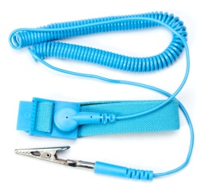
2 | ESD Grounding Cord | 18” Length Button to button | 67/pcs | 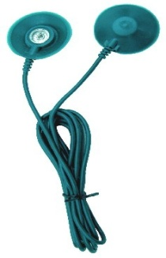
3 | Grounding Plug | 1 M length (Plug with Button) | 110/pcs | 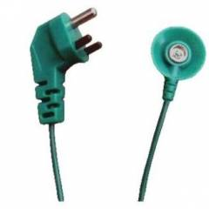
4 | Button | Male & Female | 12/pair | 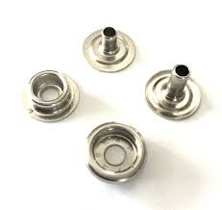
 |  | Total | 236/-Set

Terms & Conditions:

• Payment: 15 Days After Receiving material
• Delivery: 1 week after receiving of P.O.
• Freight: As Per Actual
www.indoeenterprises.com
Email: sales@indoeenterprises.com
8299544092 / 8802631025

